

Power Bench
AD-10245

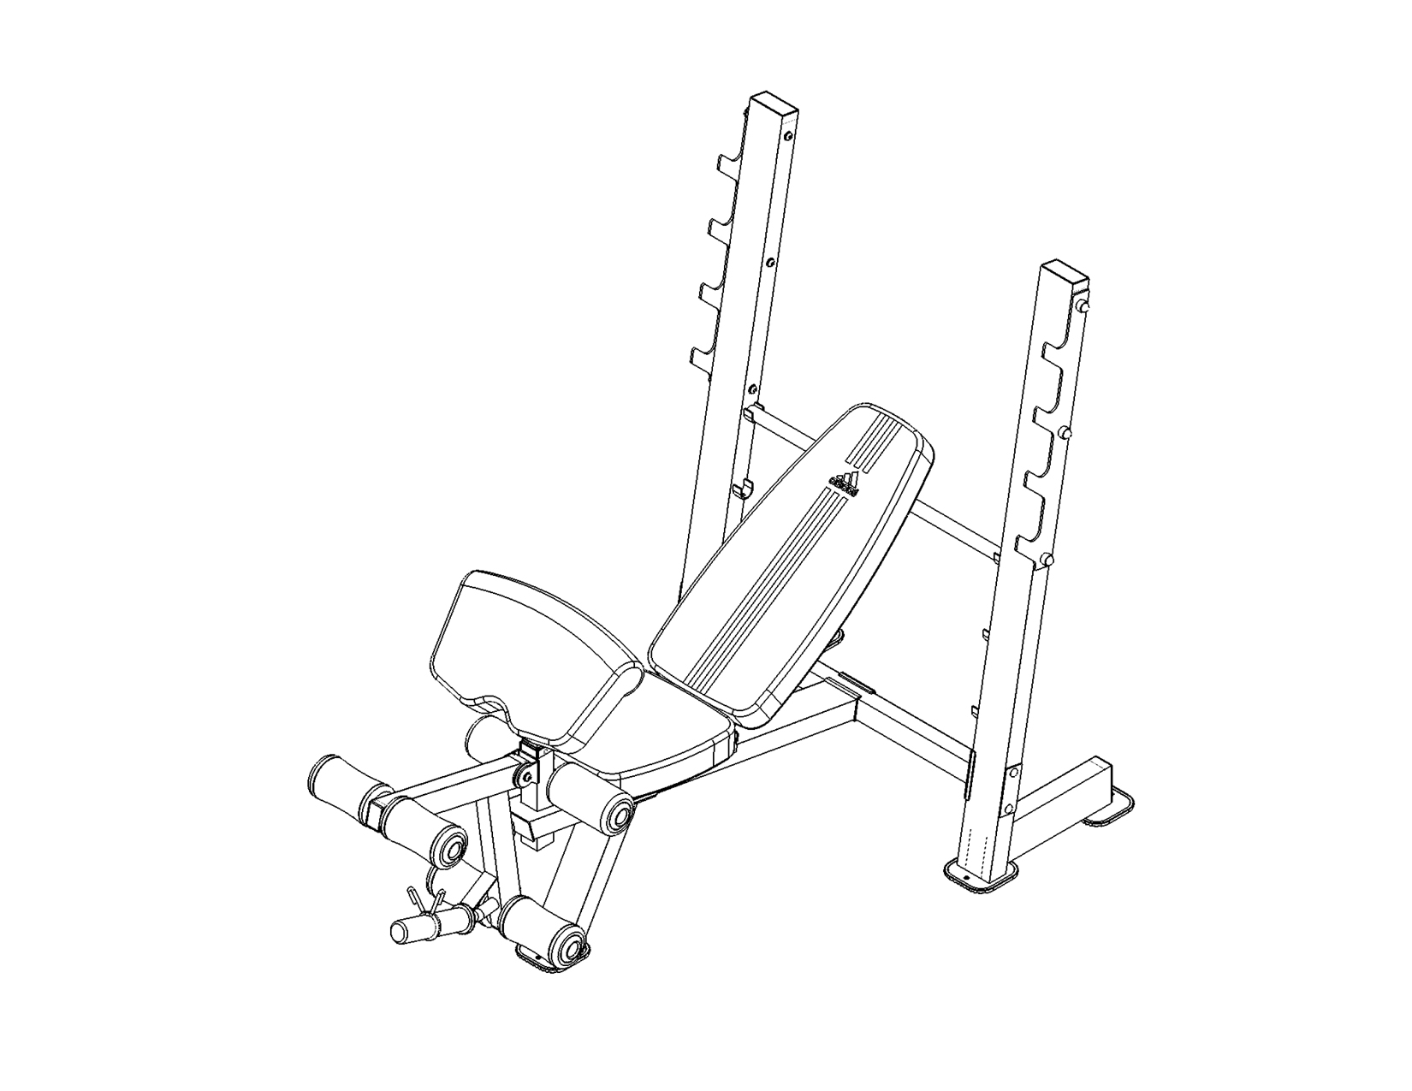

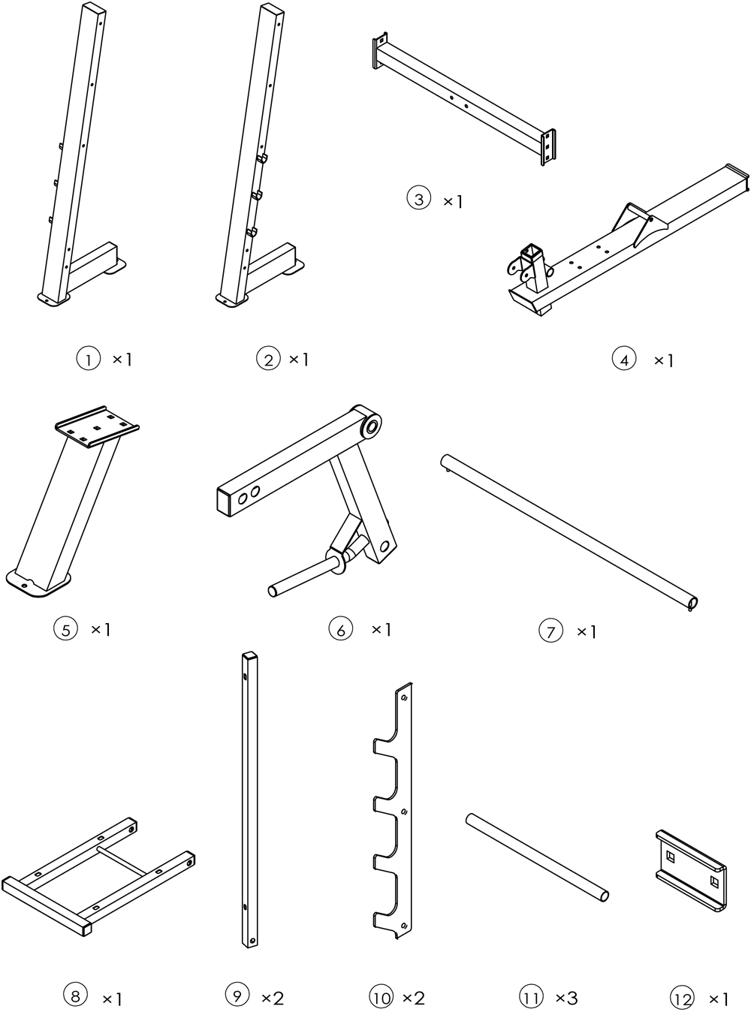
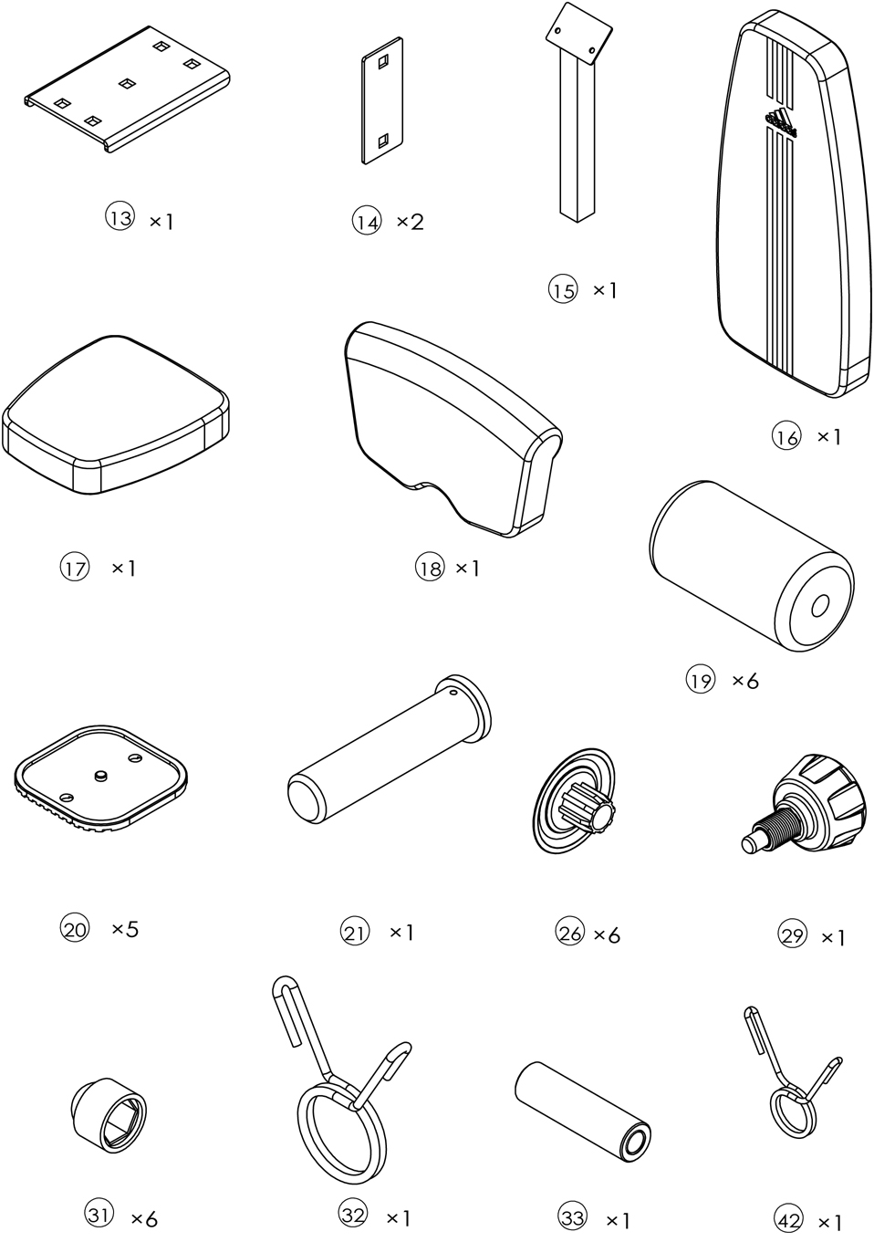
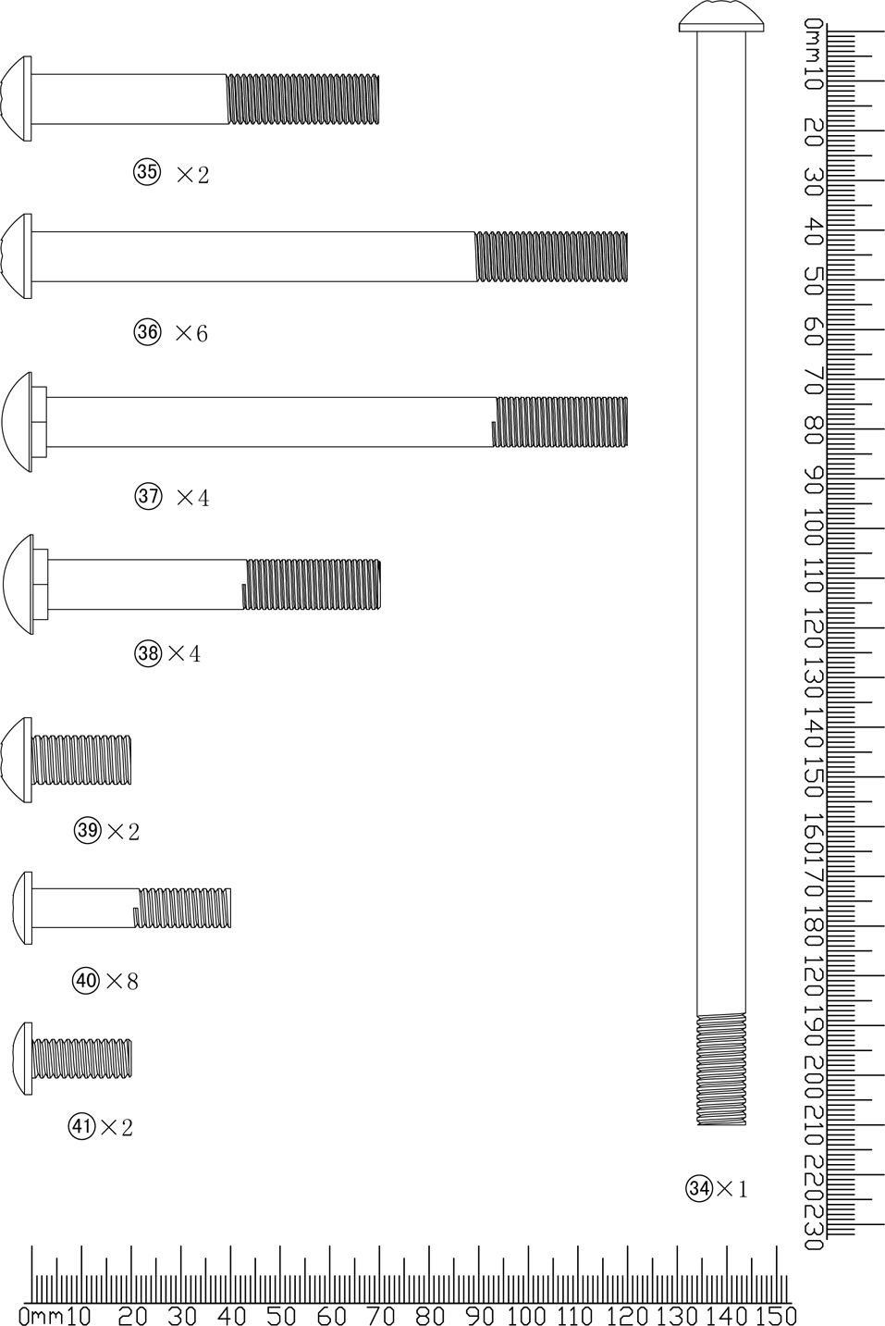
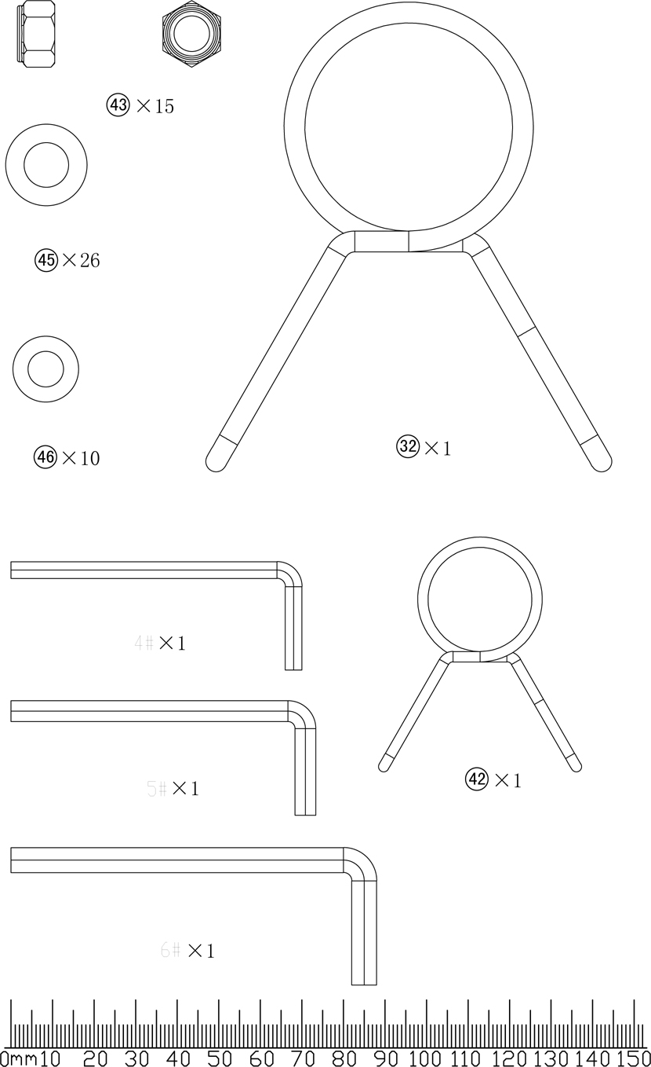
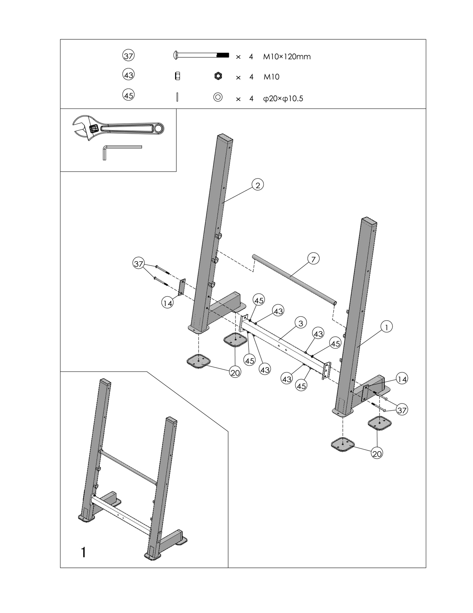
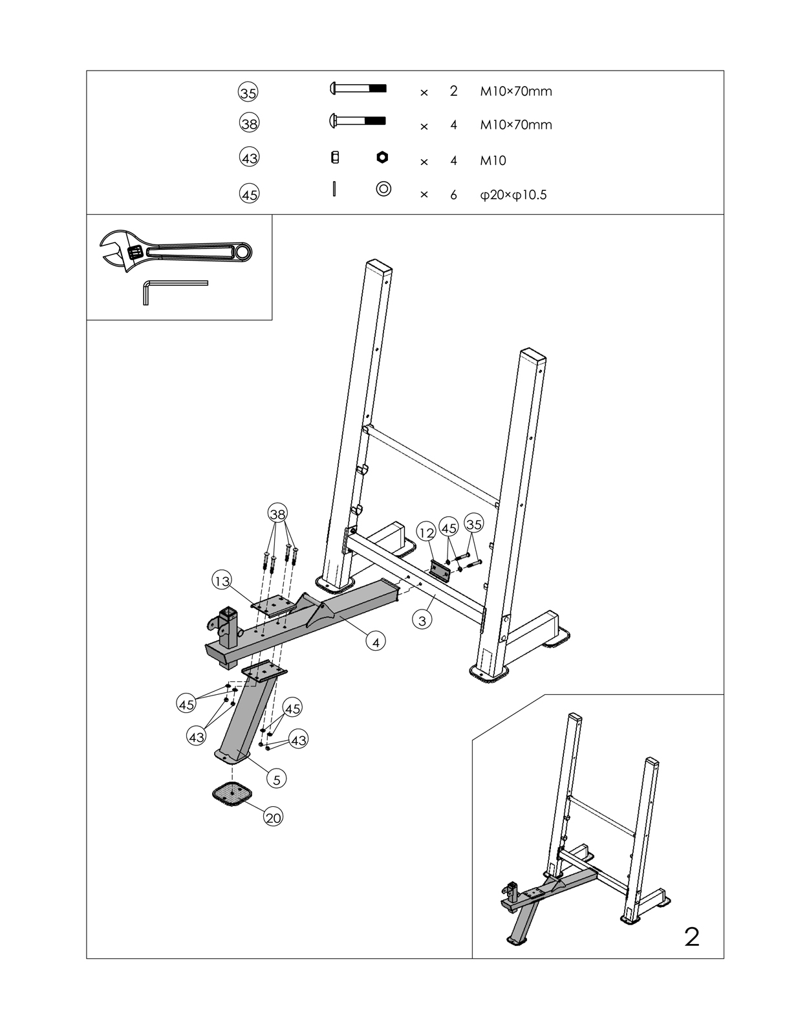
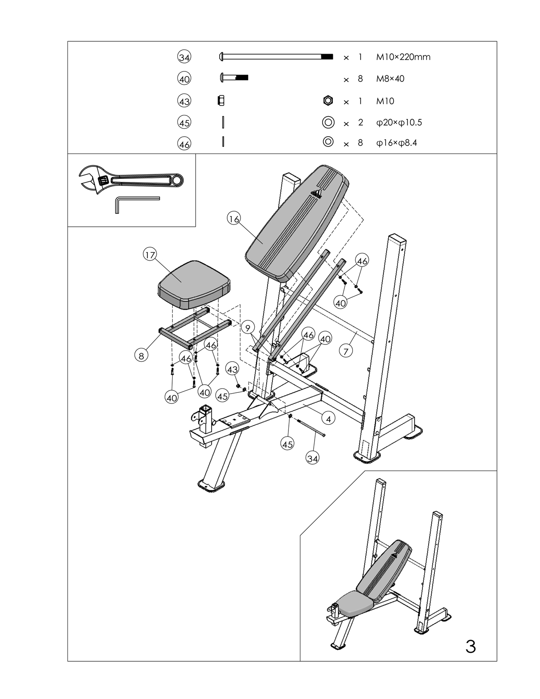
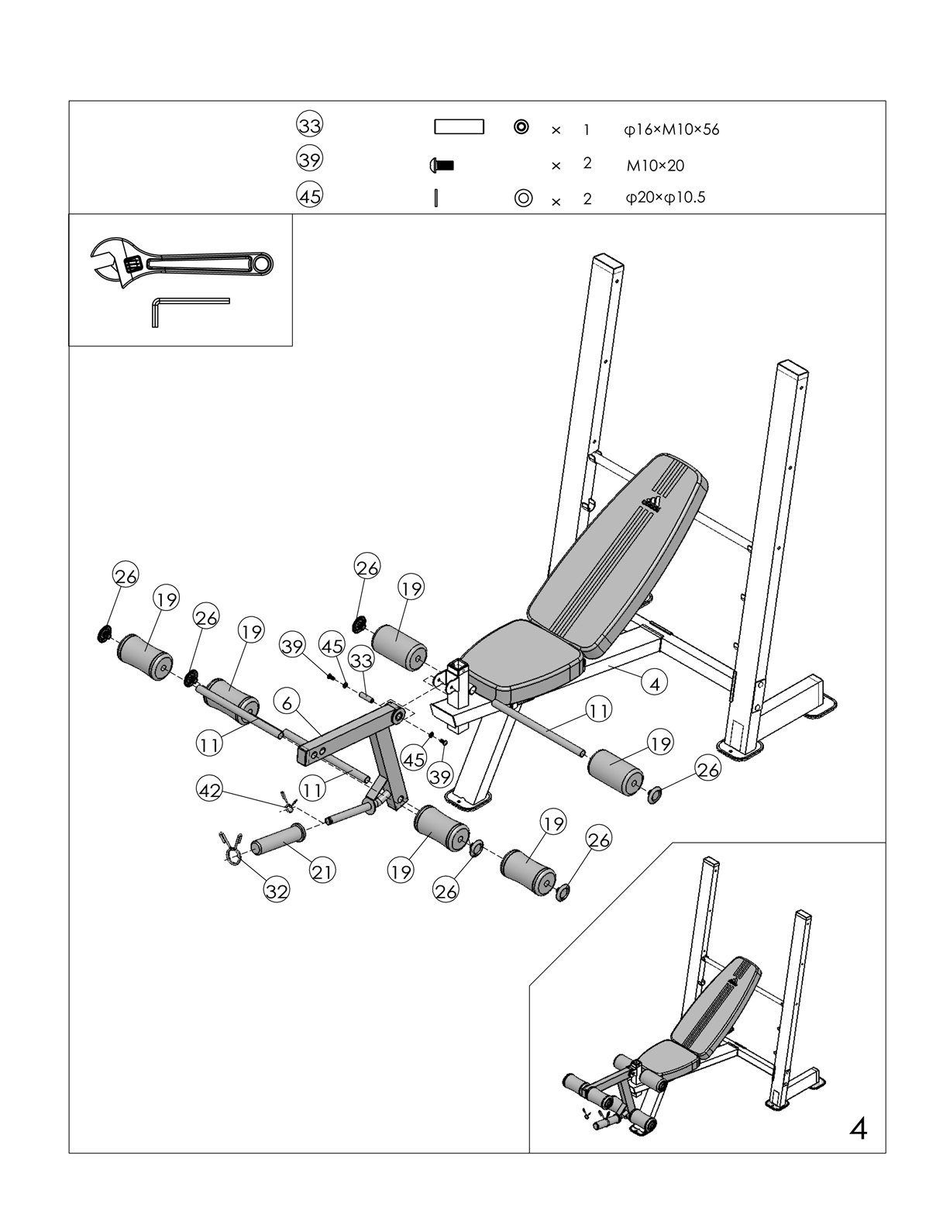
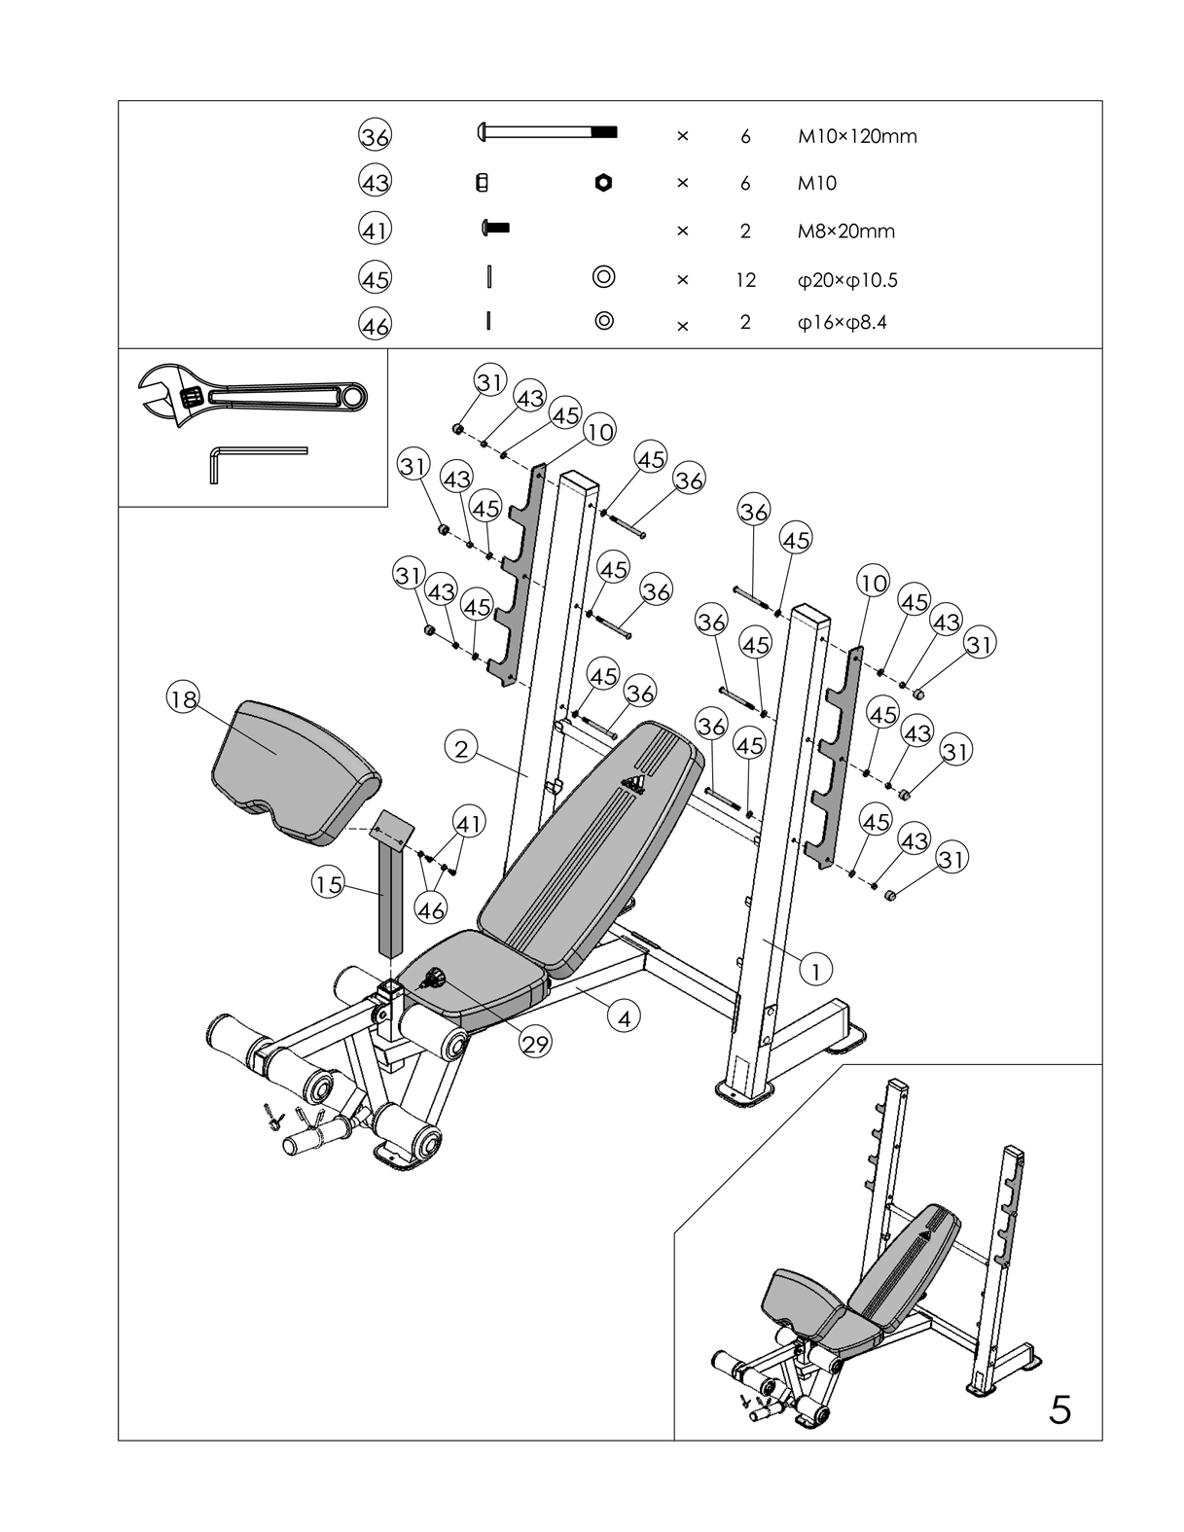

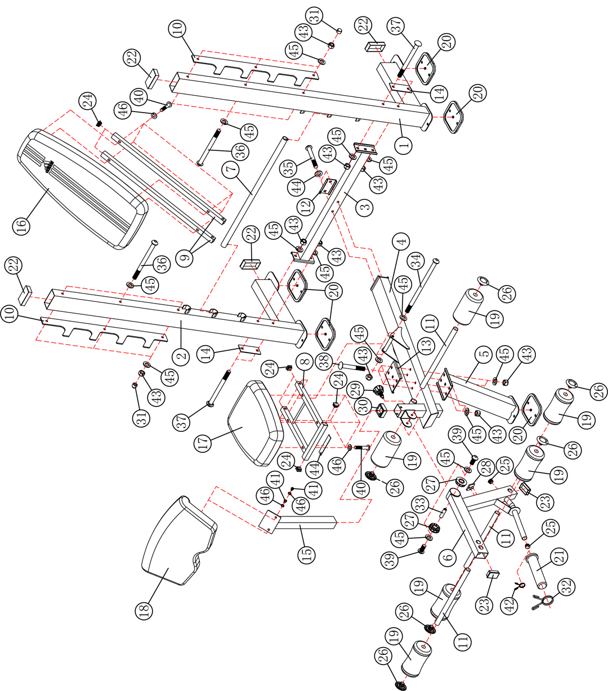

PART NO. | DESCRIPTION | DESCRIPTION GERMAN | SIZE | QTY
1 | Left Upright Beam | links stehend Strahl |  | 1
2 | Right Upright Beam | Recht aufrecht Strahl |  | 1
3 | Cross Brace | Querstrebe |  | 1
4 | Main Seat Support Frame | Hauptsitz Stützrahmen |  | 1
5 | Front Post | vorderen Pfosten |  | 1
6 | Leg Developer | Bein-Entwickler |  | 1
7 | Backrest Adjustment Bar | Lehnenverstellung bar |  | 1
8 | Seat Bracket | Sitzkonsole |  | 1
9 | Backrest Support | Rückenlehnenträger |  | 2
10 | Bar Catch Frame | bar zu fangen Rahmen |  | 2
11 | Foam Tube | Schaumrohr |  | 3
12 | Bracket | Klammer | 100mm x 50mm | 1
13 | Bracket | Klammer | 160mm x 101mm | 1
14 | Bracket | Klammer | 120mm x 50mm | 2
15 | Arm Curl Stand | Arm-Curl stehen |  | 1
16 | Backrest Board | Rückenlehne Bord |  | 1
17 | Seat Pad | Sitzpolster |  | 1
18 | Arm Curl Pad | Arm-Curl-Pad |  | 1
19 | Foam Roll | Schaumstoffrolle |  | 6
20 | Floor Base Cap | Boden Bodenkappe | 120mm x 120mm | 5
21 | Olympic Sleeve | olympic Ärmel | Ø50mm x 210mm | 1
22 | End Cap | Endkappe | 50mm x 100mm | 4
23 | End Cap | Endkappe | 60mm x 40mm | 2
24 | End Cap | Endkappe | 25mm x 25mm | 6
25 | End Cap | Endkappe | Ø25mm | 2
26 | Foam Roll End Cap | Schaumstoffrolle Endkappe |  | 6
27 | Bushing | Buchse | Ø60mm x 23mm | 2
28 | Rubber Bumper | GUMMIABWEISRAHMEN | 40mm x 40mm | 1
29 | Lock Knob | Feststellknopf | M18 | 1
30 | Sleeve | Ärmel | 50mm x 45mm | 1
31 | Bolt Cover Cap | Bolzen Abdeckkappe | M10 | 6
32 | Spring Clip | Federbügel | Ø49mm | 1
33 | Leg Developer Axle | Bein-Entwickler Achse | Ø16mm x 56mm | 1
34 | Allen Bolt | Inbusschraube | M10 x 220mm | 1
35 | Allen Bolt | Inbusschraube | M10 x 70mm | 2
36 | Allen Bolt | Inbusschraube | M10 x 120mm | 6
37 | Carriage Bolt | Schlossschraube | M10 x 120mm | 4
38 | Carriage Bolt | Schlossschraube | M10 x 70mm | 4
39 | Allen Bolt | Inbusschraube | M10 x 16mm | 2
40 | Allen Bolt | Inbusschraube | M8 x 40mm | 8
41 | Allen Bolt | Inbusschraube | M8 x 20mm | 2
42 | Spring Clip | Federbügel | Ø24.5mm | 1
43 | Aircraft Nut | Flugzeuge Mutter | M10 | 15
44 | Sand Panel | Sand-Panel |  | 1
45 | Washer | Waschmaschine | Ø10mm | 26
46 | Washer | Waschmaschine | Ø8mm | 10
 | Allen Wrench | Inbusschlüssel | 4# | 1
 | Allen Wrench | Inbusschlüssel | 5# | 1
 | Allen Wrench | Inbusschlüssel | 6# | 2



